Newtongrange Primary School

Aims Booklet

Primary 5

2017-2018

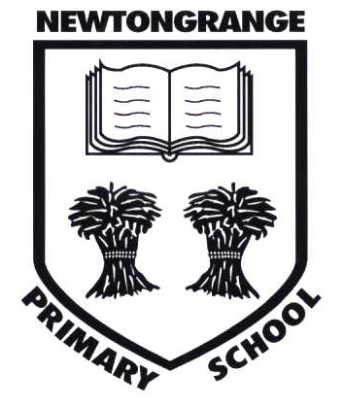

**The Curriculum in P5**

**Literacy and English**

Pupils will:

* read for enjoyment texts of differing genres, to collect information from a variety of resources, to develop comprehension skills and to be able to comment on the author’s ideas and crafts.
* develop imaginative, personal and functional writing skills by focusing on character descriptions, setting, purpose and audience. To continue to extend use of punctuation and grammar.
* develop the ability to speak with confidence in a variety of situations whilst demonstrating awareness of audience and purpose of presentation.
* to listen and respond to stories, plays, poems and instructions.

**Numeracy and Mathematics**

**First Level targets include:**

*Number, Money and Measurement –* work with numbers up to 1000, use coins up to £1.00, add and subtract two digit numbers, multiply and divide using the 2,3,4,5 & 10 times tables, find the missing numbers (e.g. 4 + ? = 11)

**Second Level targets include:**

*Number, Money and Measurement* – work with numbers up to 10,000, add and subtract mentally for one digit to and from three digit numbers (e.g. 264 – 8), multiply and divide

Using all times tables up to 10, find simple fractions of amounts (e.g. $\frac{1}{5}$ of 35), tell the time to the nearest five minutes using analogue and digital clocks.

**Progressing towards:**

*Number, Money and Measurement* – work with numbers up to one million, add and subtract, multiply and divide using numbers to two decimal places, calculate fractions and percentages of amounts (e.g. $\frac{3}{4}$ or 75% of 2400), increase accuracy of measurement to include grams, millimetres and millilitres.

**Health and Wellbeing**

Mental, emotional, social and physical wellbeing will be supported through Cool in School, Circle Time, Achievement Assemblies, and promotion of healthy eating (how to grow your own food), physical education and sport with continuous reinforcement and discussion of class and school rules. Children will continue to use their personal folios to record their achievements throughout the year.

**P.E.**

Miss Middlehurst (Monday)  
Through a variety of sporting activities, the pupils will develop their physical fitness and abilities. They will also be encouraged to develop their thinking skills, problem solving and sportsmanship.   
Class PE we will be focusing on gymnastics, athletics, games and dance.

A series of skiing lessons is made available for P5 children after the October break.

**Social Studies, Technologies and Science**

This year our projects will be:

Novel Study – Charlie and the Chocolate Factory

Ancient Egyptians

Electricity  
Light and sounds  
Scottish focus

Rainforest

Computer skills will be developed using the ICT suite and class computers for most areas of the curriculum. Children will also work in the Technology Suite for Science experiments.

**Expressive Arts**

Art, Drama, Music and Dance will be linked to current topics where appropriate.

**Art** – Observational drawing, painting, modelling and other media. The children will also study a range of artists.

**Dance** – To take part in dance from a range of styles and cultures, demonstrating my awareness of the dance features including Scottish Country dancing.

**Drama** – The pupils will develop a variety of techniques to enable them to explore topics from different points of view.

**Religious and Moral Education**

The main areas of study are Judaism, Islam and Christianity. Through the study of world religions pupils will develop their understanding of different beliefs and values.

**General Information**

We hope this leaflet is helpful in outlining the curriculum this year. Should you have any questions please do not hesitate to contact the school.

* In accordance with our healthy eating policy, we encourage children to drink milk or natural still water, rather than juice. Please ensure that water bottles are named to avoid confusion.
* Children should have a labelled P.E. kit, including a change of top (no football strips) in a named bag that is kept in school. Weather permitting they will have one indoor and one outdoor P.E. session per week. The P.E. kit will be sent home to be washed during school holiday times.
* We would ask that all clothing is marked with your child’s name. In poor weather conditions please ensure that your child comes to school wearing suitable clothing.
* If your child is going home for lunch, please send a note on the day or phone the school.
* Reading books and records should be brought to school every day.
* Homework is normally given out on a Tuesday to be returned on a Monday. If homework is not completed it would be greatly appreciated if your child could bring a note of explanation.
* Children should bring a pencil and rubber to school every day.

