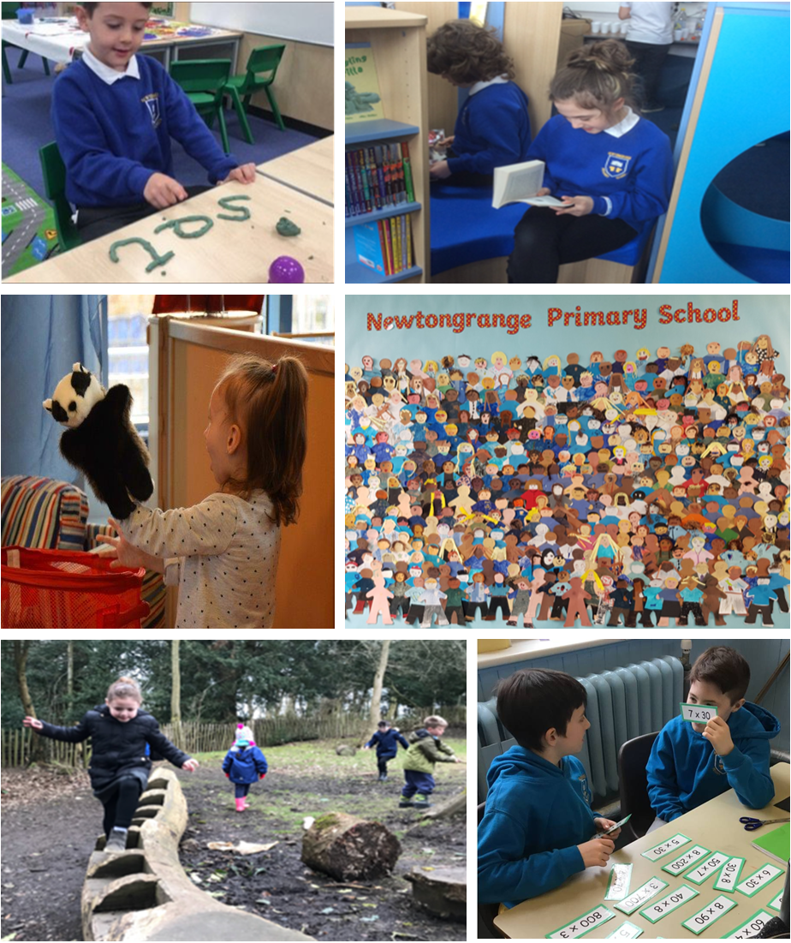
School Handbook
2017-2018

Aspire, Believe, Achieve
CONTENTS

 | Page
Welcome | 3
School Description | 4
Staff | 5
Midlothian Council Education Aims | 6
School Vision and Values | 7
School Improvement Plan | 8
Curriculum for Excellence | 8
Assessment and Reporting | 10
Pupils with Additional Support Needs | 10
Parents and Partners in their Children’s Learning | 11
Enrolment | 12
Transfer to High School | 13
The School Day | 13
School Attendance | 14
School Uniform | 15
School Transport | 15
Trips and Visits | 16
School Meals, Milk and Fruit | 16
Parent Pay | 17
Health and Safety | 18
Mobile Phone Use in School | 18
The School Health Service and Medical Care | 18
Accident Procedures | 19
Administration of Medicine | 19
Chronic Illness | 19
Guidelines on the Treatment of Head Lice | 20
Homework | 20
Religious Observance | 22
Learner Participation | 22
Extra Curricular Activities | 23
Lost Property | 23
Playground Supervision | 23
Promoting Positive Behaviour | 24
School Rules | 24
Anti Bullying Policy | 25
Child Protection | 26
School Closure and Emergency Procedures | 26
After School Club | 27
Complaint Procedures | 27
Useful Addresses | 29

WELCOME FROM THE HEADTEACHER

Dear Parent/Carer,

A warm welcome to Newtongrange Primary School. We hope you find the information contained in this handbook useful. If you are enquiring into your child attending our school please contact me and I will be happy to arrange a tour of the school for you and answer any questions you may have.

At Newtongrange Primary School we provide a safe, caring environment where every child is valued as an individual and where diversity is celebrated. We believe it is important that individual talents and interests are promoted and we aim to provide wider curriculum activities both within and out with school to support and extend skills for life, learning and work.

Newtongrange Primary School is a values based learning community where we take pride in developing all aspects of children’s learning. We have high, but realistic, expectations of our learners, both in terms of working hard in class and life outside the classroom. We encourage our learners to consider the needs of others, to be helpful and polite and look after their surroundings.

We are committed to building effective partnerships with you and the wider community so that together we can share the important task of preparing our children for the opportunities and challenges of the future, and ultimately to enable them to achieve their full potential and follow their dreams.

We offer you opportunities to share in your child’s learning through regular planned activities and we look forward to working in partnership with you and should you have any issues, concerns or ideas for improvement, please feel free to share these with us.

Newtongrange Primary School is a busy school that encourages partnership with parents and the wider community. We have an active Parent Council, an enterprising P.T. A. who organise many social and fundraising events over the school year and many parents support their children at school in a variety of ways.

We believe that learning should be enjoyable and believe that fun is an essential part of life at Newtongrange Primary School. We want our children to leave with very happy memories of their time here, having achieved success and feeling motivated and enthusiastic about their future.

If after reading this handbook you require further information about Newtongrange Primary School, please have a look at our website or contact the school.

Miss Vicky Morgan
Headteacher

NEWTONGRANGE PRIMARY SCHOOL
SIXTH STREET
NEWTONGRANGE

MIDLOTHIAN

EH22 4LB

TEL. 0131 271 4645

FAX. 0131 654 2837

EMAIL: Newtongrange_ps@midlothian.gov.uk

WEBSITE: http://newtongrange.mgfl.net/

TWITTER:@NewtongrangePS

PTA EMAIL: newtongrangepta@community.mgfl.net

SCHOOL DESCRIPTION

Newtongrange Primary School is a non-denominational school for children living within the Newtongrange community. The school is built next to the park in the centre of village. There are currently 15 primary classes from P1-P7 and a Nursery with places for 50 children to attend in the morning and 50 in the afternoon. There is a gym hall, dining hall, newly refurbished school library, nurture room, Expressive Arts room and other learning spaces. There are playground facilities at the rear of the school and classes have access to the local park to enrich learning.

The school is part of the Newbattle Learning Community and most of our P7s transfer to Newbattle Community High School. There are strong links with the high school and with the other primary schools in the learning community.

We have a highly committed staff of teachers, Child Care Development Workers (CCDW) and school support staff who provide high quality learning and teaching experiences and contribute to the daily running of the school. We have visiting specialists for music, art and PE. Children can participate in woodwind, strings and brass instrumental tuition. Playground and dinner hall supervisors help the children to develop play, stay safe and enjoy the wider experiences in school. There is a Breakfast and After School Club on site.

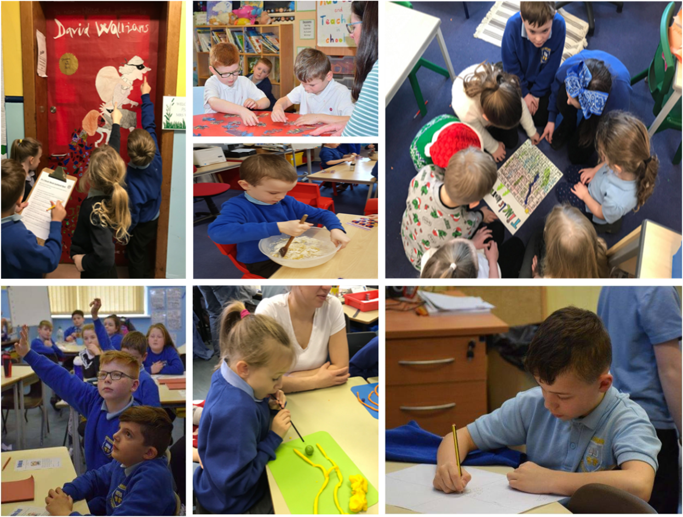
STAFFING 2017-2018

SENIOR LEADERSHIP TEAM
Head Teacher Miss Morgan
Depute Head Teacher Mrs Crossan
Depute Head Teacher Mr McBride

CLASS TEACHERS
P1a Miss Hunter NQT
P1b Mrs Mitchell (Acting Principal Teacher)
P1c Ms Wardlaw (Principal Teacher)
P2a Mrs Thomson/Mrs West
P2b Miss Bell
P3a Mr Pearson
P3b Mrs McGurn
P4a Miss Paul (Acting Principal Teacher)
P4b Miss Brown
P5a Mrs Wilson
P5b Mrs Thomson
P6a Mr Thomson
P6b Mrs Bonnar
P7a Mr McBride (Mon, Tues) Mr Deed (Wed, Thurs and Fri)
P7b Mrs McNeill (Acting Principal Teacher)
NCCT Mr Lyall

LEARNING SUPPORT
Mrs Istephan (Principal Teacher)

VISITING SPECIALISTS
Art Mrs Grieve
Music Mrs Perry
PE Miss Middlehurst
Mr Flett

LEARNING ASSISTANTS
Mrs Aitken Miss Beveridge
Mrs Cunningham Mrs Knox
Mrs Wilkinson Mrs Jameson
Miss Greig Mrs Thomson
Mrs Stables Mrs Burton

NURSERY

Vacancy (Senior C.C.D.W)

Mrs Coleman (Childcare Development Worker)

Mrs Halley (Childcare Development Worker)

Mrs Lynch (Childcare Development Worker)

Mrs Sinclair (Childcare Development Worker)

ADMIN STAFF

Mrs Freeland

Mrs Hosie

HOME/ SCHOOL PRACTITIONER
Mrs Ali Turbett

JANITOR

Mr Cunningham

PLAYGROUND AND LUNCHTIME SUPERVISORS

Mrs Sinnet

Miss Stables

MIDLOTHIAN COUNCIL
EDUCATIONAL AIMS

MISSION STATEMENT

Quality lifelong learning for all.

VISION

The Education Service in Midlothian is committed to providing lifelong learning opportunities of the highest quality leading to:

- Successful learners
- Confident individuals
- Responsible citizens
- Effective contributors

Values

The Education Service particularly values:

- The individual
- The quality of improvement
- Effective partnerships
- Service to the community
- Achievement for all

AIMS

To achieve this, the Education Service aims to be:

- Responsible
- Innovative
- Creative and Enterprising

NEWTONGRANGE PRIMARY SCHOOL
VISION AND VALUES

After consulting with learners, parents and staff about what is important in our school, we have chosen three key words that we believe will support us to make a positive difference to our learners.

Aspire, Believe, Achieve

Aspire
It is important that all our learners aspire to be the best they can be, to set high goals for themselves and to work hard to reach these. Our role, as staff and parents, is to encourage and support all learners to aspire to great things in their lives – both what they can do now and what they will do in the future.

Believe
Our learners need to have faith in themselves and believe that they can achieve what they set out to do. They need supported to develop a positive mind set for this; to overcome the challenges on route. We endeavour to encourage all learners to be confident in their abilities and work together to achieve their best.

Achieve
Every learner can achieve. We are determined to empower our learners to achieve the very best they can. We do this by providing excellent teaching, high quality resources and carefully planned learning opportunities. By working together we do whatever it takes to help ensure every learner succeeds each and every day.

Our vision at Newtongrange Primary School is underpinned by our set of core values:

Kind Fair Hardworking Confident Respectful Responsible

Our school aims are to:

- Value every child as an individual.
- Provide excellent learning and teaching experiences, which allows all learners to develop the knowledge and skills relevant to their individual needs.
- Provide an exciting, creative and challenging curriculum that is broad and balanced.
- Create a learning community, where everyone works together in a supportive environment of mutual care, respect and consideration for each other.
- Promote our learner’s health and wellbeing, encouraging self-esteem and a respect for diversity and fairness in life.
- Involve parents and carers in the work of the school and keep them fully informed of their children’s progress, valuing their contributions and support.
- Develop links with the wider community to enable the school to play a full and active role in the community which it serves.
- Manage the school resources efficiently and effectively to maintain high standards and meet the needs of the school’s continuous improvement.
- Establish learning as a life-long experience accessible to everyone involved with the school.

SCHOOL IMPROVEMENT PLAN

Each year, the school examines its successes and determines its priorities for the following school session. This information is put together to form a school improvement plan, a copy is accessible on our school website.

The National Improvement Framework (NIF) has been developed in partnership with all stakeholders to drive improvements for all children. The Framework sets out our key priorities for improvement for session 2016-2017:

- NIF 1 - Improvement in attainment, particularly in literacy and numeracy.
- NIF 2 - Closing the attainment gap between the most and least disadvantaged children.
- NIF 3 - Improvement in children and young people’s health and wellbeing.
- NIF 4 - Improvement in employability skills and sustained, positive destinations.

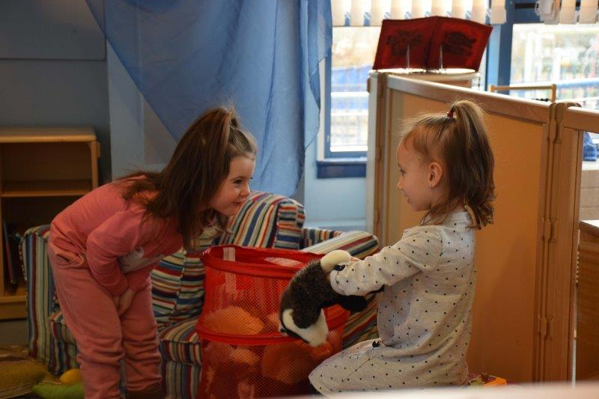 |  |  | 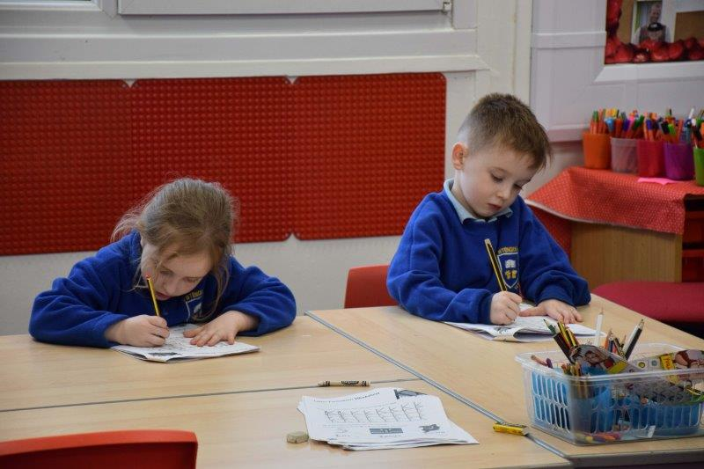

CURRICULUM FOR EXCELLENCE

Bringing learning to life and life to learning

Curriculum for Excellence is our curriculum across Scotland for all 3-18 year olds wherever they learn. It aims to raise standards, prepare our children for a future they do not yet know and equip them for jobs of tomorrow in a fast changing world.

Curriculum for Excellence enables professionals to teach subjects creatively, to work together across the school and with other schools, to share best practice and explore learning together. Teachers and practitioners will share information to plan a child’s ‘learning journey’ from 3-18, helping their progression from nursery to primary, primary to secondary and beyond, ensuring the change is smooth. They will ensure children continue to work at a pace they can cope with and with challenge they can thrive on.

Every child is entitled to a broad and deep general education, whatever their level and ability. Every single teacher and practitioner will be responsible for literacy and numeracy the language and number skills that unlock other subjects and are vital to everyday life.

It develops skills for learning, life and work to help young people go on to further study, secure work and navigate life. It brings real life into the classroom, making learning relevant and helps young people apply lessons to their life beyond the classroom. It links knowledge in one subject area to another helping children understand the world and make connections. It develops skills so that children can think for themselves, make sound judgements, challenge, enquire and find solutions.

There is personal support to help young people fulfil their potential and make the most of their opportunities with additional support wherever that is needed. There is an increased emphasis by all staff on looking after our children’s health and wellbeing to ensure that the school is a place where children feel safe and secure.

Ultimately, Curriculum for Excellence aims is to improve our children’s life chances, to nurture successful learners, confident individuals, effective contributors, and responsible citizens, building on Scotland’s reputation for great education.
THE CURRICULUM AREAS

- Expressive Arts – including art and design, dance, drama and music.
- Health and Wellbeing – mental, emotional, social and physical wellbeing, PE, food and health, substance misuse and relationships, sexual health and parenthood.
- Literacy and Languages – listening and talking, reading and writing in literacy and English and modern languages, plus classical languages and literacy and Gàidhlig/Gaelic learners (where available).
- Mathematics and numeracy – including analysing information, numbers and solving problems.
- Religious and Moral Education (denominational and non-denominational) – learning about Christianity, other world religions, and developing values and beliefs.
- Sciences – understanding important scientific concepts across planet Earth, forces, electricity and waves, biological systems, materials and topical science.
- Social Studies – understanding people, place and society in the past and present including history, geography, modern studies and business education.
- Technologies – including computing science, food, textiles, craft, design, engineering, graphics and applied technologies.

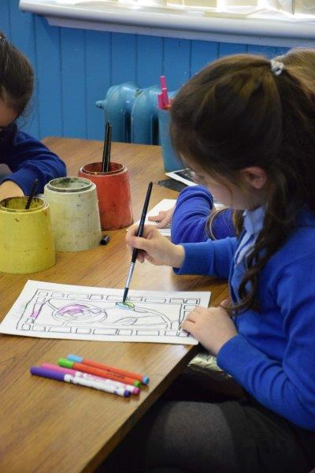 | 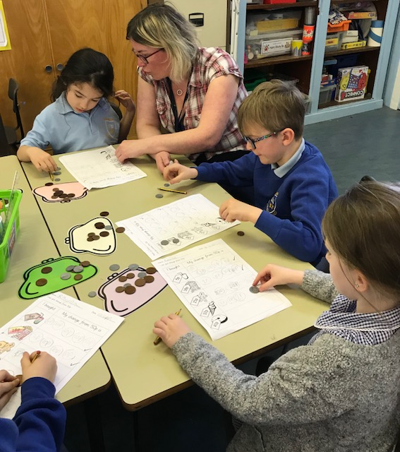

CURRICULUM LEVELS

There are national levels to describe different stages of learning and progress. For most* children, the expectation is:

LEVEL | STAGE
Early | Pre-school years and P.1 or later for some
First | To the end of P.4 but earlier or later for some
Second | To the end of P7 but earlier or later for some
Third and Fourth | S1 to S3 but earlier for some The fourth level broadly equates to SCQF level 4
Senior Phase | S4-S6 and college or other means of study

*but can be earlier/later for some as applicable, depending upon individual needs and aptitudes

Full details about Curriculum for Excellence can be found http://www.educationscotland.gov.uk/thecurriculum/

ASSESSMENT AND REPORTING

Assessment is the means of obtaining information, which allows teachers, pupils and parents to make judgements about and targets to develop pupil progress. Assessment measures the success of learning, teaching and achievement as well as guide the next steps to be achieved. The two main types of assessment used by teachers to support learning and record levels of attainment are Summative Assessment and Formative Assessment.

Summative assessment measures or summarises pupils’ achievements at the end of a unit of work e.g. using assessments to report on children’s achievements at each of the Curriculum for Excellence levels or standardised tests which are graded nationally. Children receive a level or a score for such tests.

Formative assessment focuses on planning day to day teaching and learning experiences to help pupils close the gap between what they can do and what they need to learn. It is a powerful tool for improving learning by identifying:

- What has been achieved
- What needs to be improved
- How the learning can be improved
- Who can help

In accordance with Midlothian Council Policy, all P1 pupils have a PIPS on-entry baseline assessment with a follow-up at the end of the first year in school.

To help us track individual pupil progress from Primary 2 to Primary 7, we carry out nationally approved standardised assessments in reading, spelling and maths in all classes. Results of these assessments are analysed against a National average. Results are used by teachers to help form groups and allocate support for learning to meet pupils needs.

Parents have the opportunity to meet with teachers to discuss pupil attainment and achievement at a Curriculum Evening early in the new session and by appointment two times a year at Parents Consultation Evenings. However, parents are always welcome to contact the school at any time throughout the year should they wish to discuss their child.

The school will report to parent’s using Local Authority SEEMIS reports annually in June.

PUPILS WITH ADDITIONAL SUPPORT NEEDS

Midlothian Council policy ‘Education for All’ promotes the provision for all children in mainstream education.

Midlothian Council operates a staged system of assessment and planning to reduce barriers to learning for children and young people. The authority keeps the additional support needs of each such child and young person under consideration through the Midlothian Assessment and Planning Staged System (MAPSS) process.

It is Midlothian’s policy to have a whole school approach to making all staff aware of effective practice in supporting pupils’ needs. Learners and their parents are actively involved throughout the process of assessment and planning.

The teacher carries out observations and when they recognise that a learner is requiring support they consult with the Support for Learning Teacher. Assessment information and any other relevant documents in the PPR are referred to, for example evidence of spoken language difficulties at the pre-school stage.

The teachers draw up a profile of strengths and barriers to learning and discuss strategies to inform planning for future learning. This may mean identifying classroom strategies or it can take the form of an Individual Education Plan or I.E.P. Promoted staff with responsibility for Support for Learning in the school, are part of this assessment process.

Parents and pupils are involved in setting up, where appropriate, an Individual Education Plan for their child. This identifies specific and measurable long and/or short term targets, in consultation with school staff and potentially outside support agencies. The school will also agree with parents a regular arrangement for monitoring pupil progress in their targets and the arrangements and timescales for meetings with school staff and any outside agency staff who may involved in supporting a pupil.

If you wish to discuss your child’s progress at any time with the school Learning Support Team, please contact the school to arrange an appointment.

INCLDUING ALL PUPILS

Midlothian has a policy of ensuring the inclusion of pupils with additional needs, including pupils with significant special needs. One of our stated aims is to ‘motivate and encourage children to achieve their full potential - academically, socially, morally and emotionally.’ However, it is recognised that some children may require additional time band resources to meet their needs. Direct support may involve working with pupils out with their class but is frequently classroom-based. Our learning support teachers, learning assistants and class teachers work very much as part of a team in quickly identifying and addressing support strategies appropriate to pupils with additional support needs.

PARENTS AS PARTNERS IN THEIR CHILDREN’S LEARNING

The Scottish Schools Parental Involvement Act (2006) recognises the vital role that parents play in supporting their children’s learning by modernising and strengthening the framework for supporting parental involvement in school education. It aims to help parents to be:

- Involved with their child’s education and learning.
- Welcomed as an active participant in the life of the school.
- Encouraged to express their views on school education generally.

There are three main ways parents can get involved in supporting their children’s learning:

LEARNING AT HOME

We recognise the important role of parents as the first and ongoing educators of their own children. We appreciate the support of parents in preparing children for Nursery and school, completing homework tasks and communicating with schools about important events in their children’s lives. We can offer support and advice through local groups such as Health Visitors, school nurse, Child and Family Mental Health (CAMHS) team, nurseries, parenting support groups, library and MALANI.

HOME/ SCHOOL PARTNERSHIP

We value the support of parents as part of wider learning and encourage parents to take on regular roles as helpers in school supporting pupils learning phonics, reading and number bonds. Parent helpers are also appreciated in practical subjects such as cooking and art and craft activities. Many parents volunteer to support classes on their trips and visits associated with classroom learning.

PARENTAL REPRSENTATION

The 2006 Act provides a framework for ensuring that parents have the opportunity to express their views and have these taken into account on policy matters affecting the education of their children. It makes provision for parents to be a member of the Parents Forum at a school and to have their views represented to the school, education authority and others through a representative Parent Council for the school.

Newtongrange Primary School has an elected Parent Council who can be contacted directly, through the blue post boxes in the playground at the front door and in the infant playground, by approaching a parent member or attending a Parent Council meeting. Dates of Parent Council meetings are advertised in the fortnightly school Newsletter.

The Chair of the School Council is Ms L Nelson.

Formal consultation on the School Improvement Priorities takes place via the Parent Council meetings. Parent Council representatives are invited to attend the SIP planning sessions in February and May when key priorities are identified and Action Plans formulated.

In addition Parents views on school developments are sought annually at Parents Night using questionnaires and through the School Council survey and message boards. Parents routinely comment on their child and school progress on return slips from report cards.

The Parent Teacher Association (PTA) is a sub-committee of the Parent Council. Members organise events and support activities which complement wider parental involvement including Christmas Fair, Beetle Drive and school discos.

The Chair of the PTA is Mrs T McNicol.

Parents are welcome to contact the school at any time to make arrangements for visits to school - or discussions. An appointment should be made to ensure that appropriate staff are available to talk to you.

ENROLMENT

Parents seeking information regarding enrolment of children at any stage in the school are invited to telephone the school to arrange a visit and to meet with Miss Morgan, the Head Teacher (0131 271 4645).

Enrolments of pupils due to commence Primary 1 in August of the following academic year will take place in December. Midlothian Council’s Education Division usually places advertisements regarding this in the local papers and writes to every child advising them of their catchment school. Letters will also be given to parents of Nursery Class children at Newtongrange Nursery School. To ensure that your child is enrolled in our school we require you to complete a Pupil Enrolment Form and bring it to the School Office along with your child’s Birth Certificate which we will copy and return.

A child who reaches the age of five years between the 1 March in any year and the last day of the following February, is eligible for admission to Primary School on the first day of the Autumn Term.

New intake children and their parents are invited to school in May or June to meet each other and their teacher and to become familiar with the classroom. The date of this meeting is notified by letter to parents who have enrolled a child. At this meeting you will be given the date and time that you should bring your child on their first day.

It is important that you attend these meetings so that you can discuss any areas of concern with staff and have your child begin school with confidence. We encourage regular and co-operative contact between school and parents at this important stage.

ENROLMENT INTO PRIMARY 2 – PRIMARY 7

Enrolment to P2 - P7 stages simply involves coming to the school office, asking for and completing the enrolment forms. Providing there is capacity in the class, a place will be offered. We encourage visits before enrolling to view the school and to meet key members of staff. An opportunity to visit can be arranged by phoning the school on 0131 271 4645.

TRANSFER TO HIGH SCHOOL

At the end of their Primary 7 year, pupils normally transfer to Newbattle High School. Parents of Primary 7 children are informed of the transfer arrangements by December of their child’s last year in primary school and they are invited to parents’ meetings at the High School at this time. During the summer term, visits to the High School are organised and at this time there is a very close exchange of information between the High School staff and Primary 7 teachers. This is done to ensure that the transition from primary to secondary school is an easy and happy process for the learners and parents/carers.

OUT OF CATHCMENT PLACING REQUESTS

If you do not live in the catchment area but wish your child to attend Newtongrange Primary School you have to accept your child’s place in their catchment school but complete the Placing Request Form which you will receive from Midlothian Council. The council will then contact you to let you know if you have been successful in your request.

THE SCHOOL DAY

P1-3
Monday – Thursday | 8:45am – 10:30am
 | 10:30am – 10:45am | Interval
 | 10:45am – 12:15pm
 | 12:15pm – 13:00pm | Lunch
 | 13:00pm – 15:10pm
Friday | 8:45am – 10:30am
 | 10:30am – 10:45am | Interval
 | 10:45am – 12:20pm

P4-7
Monday – Thursday | 8:45am – 10:30am
 | 10:30am – 10:45am | Interval
 | 10:45am – 12:30pm
 | 12:30pm – 13:15pm | Lunch
 | 13:15pm – 15:10pm
Friday | 8:45am – 10:30am
 | 10:30am – 10:45am | Interval
 | 10:45am – 12:20pm

At the start of the session, the P1 Intake class will attend in the mornings only for the first week.

THE NURSERY DAY

There are separate afternoon and morning Nursery classes, for which children may enrol at three years of age. When parents enrol their child in the Nursery, this does not guarantee their child a place in P1.

AM Class
Monday – Friday | 8:30am – 11:40am
PM Class
Monday – Friday | 12:25pm – 3:35pm

SCHOOL ATTENDANCE

Excellent attendance at school is important to allow your child to fulfil their potential and for them to have the best possible start in life. Midlothian Council have an expectation that all children of primary school age’s attendance should be at least 95%. Schools have the responsibility to work in partnership with families to ensure children attend school regularly.

Parents are responsible for ensuring that their child attends school regularly. It is important that pupils are punctual and parents and carers must ensure that their child is at school by 8.45am each morning.

In cases of unsatisfactory attendance or persistent lateness the school follows guidance from Midlothian Council. When a child’s attendance falls below 95% the school will seek cooperation with parents and carers to work in partnership to improve attendance.

Our school expectation is for all children to arrive on time and enter the school via their class line each morning. Children who are persistently late miss a significant amount learning. Where there have been persistent incidents of lateness, co-operation of the parents and carers will be sought by the school to work together to improve punctuality.

If your child is unable to attend school or is going to be late to school parents should telephone the school (0131 271 4645) by 09:30 a.m. If no phone call is received we will endeavour to make contact with parents/guardians by text and/or phone.

If there is anything that we can do as a school to support you with your child’s attendance please do not hesitate to contact our Home School Practitioner.

For reasons of safety children should not arrive at school too early. Children should come directly to school and arrive in the playground approximately 8.40 am. Children are discouraged from playing in the park on their way to school for their safety and to encourage good time-keeping. There is no school supervision of the park area in the event of an accident or a fight. A Breakfast Club operates on site. We will provide details for parents who wish to make use of it.

Parents are requested to make every effort to take holidays out with school term time, to minimise disruption to class work. It is only under exceptional circumstances for schools to authorise a family holiday during term time.

Where a parent experiences difficulty obtaining leave during school holidays, a judgement will be applied in such cases where evidence is provided by the employer that it cannot accommodate leave during school holidays without serious consequences.

SCHOOL UNIFORM

The wearing of school uniform is expected at all stages. We ask that all parents support us by encouraging their child to wear school uniform for the duration of their time at Newtongrange. All clothing must be labelled clearly with your child’s name. Uniforms are available through the school.

- Grey/Black/ Navy skirt, trousers or shorts (no jeans)
- Royal Blue Sweatshirt
- White Polo Shirt
- Children in Primary Seven wear blue hoodies.

PE KIT

- Gym shoes
- Gym top/T-shirt
- Shorts and/or Tracksuit bottoms
- Swimming costume (P.5 only)

At times PE takes place outside so children are advised to bring suitable clothing. PE is an important part of the curriculum and all children are expected to have PE kit in school every day. Football strips or colours are not allowed. Any child without PE kit is in a situation where they may not be allowed to take part – this is left to the teacher’s discretion, according to safety issues and individual circumstances. No jewellery should be worn by any child during the course of physical education activities, including swimming. This rule is designed to ensure the well-being of all children. Again all clothing must be marked clearly with the child's name.

The Authority operates a scheme of clothing grants to assist parents in ensuring that a pupil is sufficiently and suitably clad to take full advantage of the education provided. Families in receipt of Income-based Job Seekers allowance, on Income Support or Child Tax Credit but not Working Tax Credit (subject to a maximum annual income), both maximum Child Tax Credit and maximum Working Tax Credit (subject to a maximum annual income) or support under Part VI or the Immigration and Asylum Act 1999 will automatically qualify for such a scheme. Other cases will be determined according to the personal circumstances of the family. Parents who wish to apply for the scheme should complete an application form which is available from this school or the Education and Children’s Services Division, Fairfield House, 8 Lothian Road, Dalkeith EH22 3ZG.

SCHOOL TRANSPORT

Most of our pupils walk to school. The Authority’s current policy is to pay the travel expenses of those pupils attending the district school who live more that two miles from that school. Forms and further information is available from the transport section (please refer to Useful Addresses section of this handbook).

Bus passes are issued where public transport exists. Contract transport is arranged where there is no suitable public transport. Where there are vacant seats on contract buses, these may be made available to pupils who are attending the district school and who are not normally entitled to free transport; however a charge may be made for this service.

Transport costs are also met in the case of any pupil whom the Authority requires to attend a school other than the district school, if the pupil meets the distance qualification. Where, appropriate, free travel is provided for pupils receiving special education.

Consideration may also be given to requests for assistance with travel in exceptional circumstances, e.g. where the road between home and school is deemed dangerous by the Authority, and where there is no public transport available. Parents who choose to send their children a school other than their catchment school, will not receive assistance in relation to travel to and from school.

Trips and Visits: When pupils are transported as part of a trip or visit all buses are booked through providers registered with the Local Authority. Minibus drivers have all have current MIDAS qualifications and Local Authority Insurance.

TRIPS AND VISITS

SCHOOL TRIPS

During the school year many of our classes will organise educational trips that will help to deepen their knowledge and understanding of a particular subject. These trips are seen as part of your child’s education and are a valuable learning tool. There will often be a cost for these trips. We strive to keep costs to a minimal and you will be advised when necessary.

RESIDENTIAL TRIP

A residential trip to an activity centre is organised for all P7 pupils. Planning for this trip will take place early in the P7 year and parents are invited to a meeting to discuss the aims of the trip and any requirements that may be necessary.

CLASS VISITS

Throughout the school year class teachers often organise visitors to come to the classroom to share their knowledge and expertise with the children. These visits are extremely valuable and allow the children to speak to and work with many different people from different walks of life. If you have something of interest that you could share with a class please let your child’s class teacher know. Visitors always enter the school through the Main Entrance and report to the Office to sign in where they will receive a ‘visitor badge’.

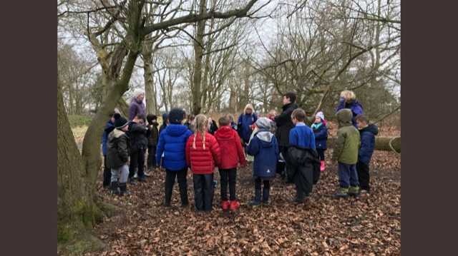 | 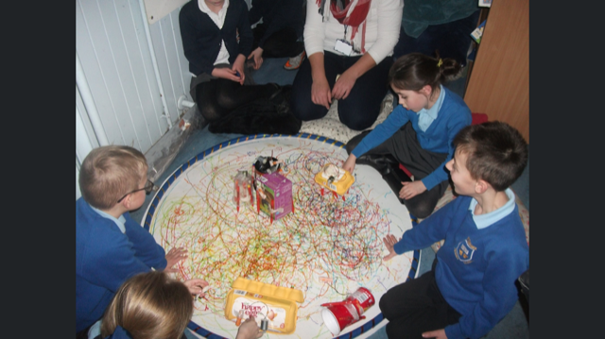

SCHOOL MEALS, MILK AND FRUIT

At Newtongrange, we encourage and support the concept of Healthy Eating. We are committed to encouraging children to make informed healthy eating choices through our ‘Healthy Eaters’ initiative. The Education Authority and Midlothian Catering Services aim to promote healthy choice and balance in our children’s eating habits, both in our school meals service and through the school curriculum. By working together, we provide our children with the life skills necessary to make informed healthy choices.

If you are sending a Packed Lunch with your child, we would ask you to support us in our aim to encourage Healthy Eating. Please do not include sweets, chewing gum or fizzy drinks. We are happy to provide advice and support about Healthy Packed Lunches.

Pupils having either school meals or their own packed lunch both enjoy lunch together in the dining area. Lunch times are supervised with reasonable manners and eating habits are encouraged and expected from all. The Positive Relationships, Positive Behaviour, Positive Learning Policy applies in the Dining Hall.

Menus are sent home regularly so parents can help children choose their meals. Menus are displayed on the school website. The cost of a two-course meal, as of August 2017 is £1.90 for P4 – 7 pupils. All P1–3 children are entitled to a free school lunch.

All children in P1 and P2 are offered fresh fruit three times a week to encourage them to try new tastes.

Under the Education Committee’s policy, children in attendance at schools under the management of the Authority are entitled to free school meals and milk if their parents are in receipt of Income Support or an Income Based Jobseeker’s Allowance and Child Tax Credit (subject to a maximum income). Children attending certain special schools where eating skills and the midday meal are part of the educational programme also receive free meals. Milk will be available to all other children in education at favourable prices.

Further information and an application form can be obtained from the school or from:-
Free Meals and Free Clothing Section, Education Division, Fairfield House, 8 Lothian Road, Dalkeith, EH22 3ZG.

SCHOOL MILK

You may order milk from school. This is issued daily in 1/3-pint cartons. The milk can be ordered annually or termly. A note of the cost is sent home at the start of each term. Milk is subsidised by Midlothian Council. Free milk will be available to all children in nursery education and to children of primary school age at primary and special schools if their parents are in receipt of the benefits as outlined above for Free School Meals.

WE AIM TO BE A NUT-FREE SCHOOL

Although we are unable to guarantee pupils do not bring products containing nuts to school, there are children in our school with nut allergies and we ask parental co-operation that products containing nuts are not sent to school as snacks or including in packed lunches.

PARENT PAY ONLINE PAYMENT SYSTEM

ParentPay offers a more convenient way to pay for school meals, milk, trips and much more online. The system also enables parents, including parents of children entitled to free school meals, to choose school meals online. Our aim is to make the school a cashfree environment.

You will receive your unique ParentPay Account activation details and full step-by-step instructions on how to log in to the system. If you do not have an account, please ask at the school office for help setting this up.

You will have a secure online account, activated using a unique username and password; you will be prompted to change these, and to keep them safe and secure. If you have more than one child at our school, or children at another ParentPay school, you can create one single account login for all your children regardless of which school they attend.

Making a payment is straightforward and ParentPay holds a payment history for you to view at a later date; no card details are stored in any part of the system. Once you have activated your account you can make online payments straight away.
If you have any difficulties in using the system please speak to the office staff who will offer you support.

HEALTH AND SAFETY

The Education and Communities Division has prepared policy statements on Health and Safety for all areas of its responsibility in accordance with the Health and Safety at Work Act 1974. School staff are fully instructed in their responsibilities in this respect, and safety regulations apply to all aspects of school life, both on and off the premises. It is expected that pupils will behave responsibly and comply with all safety requirements. The support of parents in promoting good practice in health and safety matters is of great importance to the school.

For safety and security we would ask that children arrive at school and exit the building via the designated doors for their year/stage.

Parents/Carers wishing to speak to the class teacher should contact the school office to make an appointment. Parents/Carers should not enter the school building at any point other than through the main office entrance.

FIRE DRILLS

Fire evacuation procedures are displayed in every room. There are termly fire drills throughout the school year. The first of these are “announced” so that children can be reminded of procedures and reassured. The others are unannounced with children and adults evacuating the building as they would in a real emergency and congregating at the bottom part of the upper school playground.

SCHOOL SECUIRTY

We have a fully operational school security system, the following points should be noted:

- Parents/Visitors to school will only be able to enter through the main door entry system.
- At the end we expect parents/ carers to wait in the playground until the children exit from the building.
- Children who arrive late for school will be unable to gain access by their normal door and will consequently need to enter by the main door entry system and will be marked late on the register.
- Parents who wish to talk to the Teachers will be able to do so by contacting the School Office and arranging a suitable time to meet.

MOBILE PHONE USE IN SCHOOL

Our school recognises that for health and safety reasons some parents may wish their child to have a mobile phone. Children bringing a mobile phone to school must hand their phone in first thing in the morning for safe keeping and they will be given their phone back at the end of the day. If a child is found with a phone but has not handed it in for safe keeping that phone will be confiscated and parents/carers themselves will be asked to pick up the phone at the end of the day. We hope you will support this arrangement which we are putting in place to ensure the safety of children and appropriate use of mobile phones in school. However, please also note that, in spite of these arrangements and our best efforts, we cannot be held responsible if your child’s mobile phone is lost, stolen or broken when in school.

THE SCHOOL HEALTH SERVICE AND MEDICAL CARE

Throughout their time at school a team of specialist Health Service and Education staff will be seeing children as part of a planned programme to make sure that they benefit as much as possible from all that school has to offer and to help prepare them for life after leaving school. The school health service is part of Midlothian’s Community Child Health Service and has direct links with those who carry out health checks on children before they start school.

School Nurse - the lead health professional in mainstream schools in Midlothian. School nurses are involved with health promotion and education, prevention of ill health, immunisation, health surveillance and screening. The school nurse may be helped by a health assistant and have close working links with community paediatricians. The school nurse reviews the notes of all children in Primary 1 as well as those of all new entrants. A member of the school health team measures their growth and tests vision. The school nurse will assess these measurements and results. In addition she may review children who are referred either by parents, teachers or other health professionals at any stage in their school life.

- If you have concerns about your child’s hearing the school can refer him or her to the appropriate specialist directly.
- Speech and Language Therapist - can provide assessment and, if necessary, support if you, a teacher, your GP or the school doctor feels that your child may need help with communication.
- Any enquiries concerning the provision of dental services should be made to the Director of the Community Dental Service, 16 Duncan Street, Edinburgh EH9 1SR (Telephone: 0131 667 7114).
- We hope that the School Health Service can, together with yourselves, contribute to your child’s overall well-being and development. Please do not hesitate to arrange through the Head Teacher to see the school doctor, school nurse or the health visitor if you want any information.

MEDICAL CARE

It is essential the school be advised of any special medical conditions or requirements involving your child, particularly in respect of conditions which may require essential or emergency administration of medication. This ensures the school acts appropriately should a medical situation arise. Forms are available from school for parents to complete in respect of the administration of medication to their child in school. Should a child advise of illness during the school day, parents may require to be called to collect the child. Please note children are not allowed out of school unaccompanied for any reason and in the event of a planned appointment during the school day, parents should report to reception to arrange the pupil to be collected from class. For reasons of health and safety, it is not appropriate for a pupil to wait at the school door or gate.

ACCIDENT PROCEDURE

In the event of a child having a serious accident, the school will arrange immediate medical assistance and then telephone the parent/carer. If they are uncontactable, the emergency contact will be called. In the case of a less serious incident, we contact the parent/carer in the first instance. It must be stressed that the Qualified First Aider can provide only an emergency first aid service for part of the school day.

CONTACT DETAILS

Emergency contact details should be provided to the school at the time of enrolment, and should be kept up to date.

ADMINISTRATION OF MEDICINE

There is no obligation on school staff to administer medication of any kind to any pupil. You are asked to note that non-prescription medicine (e.g. Calpol, cough medicine, nose/eye drops, painkillers, etc.) will not be administered by the school unless there is a prescription label – the local pharmacist can help organise this.

Where pupils require regular prescription medication to be administered or self administered during the school day, parents/carers must complete the relevant request form available from the School Office. They must include written guidance from a medical professional (your GP or Specialist/Chemist). The written prescription label on the bottle will usually be sufficient.

INHALERS

Some pupils carry inhalers for asthma and related illnesses, which they self-administer at school. It is necessary that parents of pupils who carry their own medication complete the appropriate form so that an up-to-date record is held for each child carrying medication to school. Parents must ensure inhalers are regularly updated.

CHRONIC ILLNESS

If a pupil suffers from a chronic illness requiring long-term medication or where medication may be required in an emergency situation, parents must contact the Head Teacher to discuss the situation. Separate guidance detailing arrangements for dealing with the medical condition requiring essential or emergency treatment has been prepared by the Education Division and will be made available to parents, if required.

Please ask for a copy of these forms as required:

- Regular medicine given by staff – MED1
- Regular medicine (including inhalers) taken by pupil in school – MED 2

No pupil who appears to be ill should be sent to school. Such cases should be referred by parents to their local doctor for diagnosis and treatment.

GUIDELINES ON THE TREATMENT OF HEAD LICE

Although the Scottish Government has directed that schools no longer issue letters home when instances of headlice are reported, we believe it would be helpful to send out information to all families on a regular basis.

The most recent guidance for treating head lice can be found on the following website:
http://www.nhs.uk/Conditions/Head-lice/Pages/Treatment.aspx

In summary the guidance is as follows: after a head lice infestation has been confirmed you can treat the lice at home by wet combing the hair with a head lice comb or by using a lotion or spray that's designed to kill head lice.

We hope that the School Health Service can, together with yourselves, contribute to your child’s overall wellbeing and development. Please do not hesitate to arrange through the Head Teacher to see the school doctor, school nurse or the health visitor if you want any information.

HOMEWORK

We value the important role homework plays in providing a ‘learning bridge’ between home and school. It also provides children with the means to practice and extend their school learning and begin developing study skills for the future.

Homework can be many different types of learning that take place outside school. It is an activity relevant to the pupils’ class work and a way of communicating with home about the work covered in class. The type and timing of tasks set varies across the stages of the school. Homework is usually set Monday to Friday.

When setting homework teachers should:

- Ensure tasks are clearly explained.
- Encourage sharing of learning with parents and carers.
- Consolidate work taught at school and so raise attainment.
- Encourage the development of the skills of independent learning.
- Encourage the development of good study habits.
- Build confidence through discussion with parents, carers and families.
- Encourage use of wider resources such as local library, interviewing family members, visiting, model making or gathering evidence.
- Be sensitive to the commitments of families and carers.

NURSERY

Children are invited to bring photographs and items for the current topic to be discussed and displayed on the Learning Wall. Parents are asked to share the Pupil Folio with their children and make comments on their learning experiences.

P1 - P2 children will typically be asked to:
- Discuss a pre-reading or library book.
- Share a story or number sack.
- Practice pages of reading.
- Reinforce sounds or words using a workbook with oral and written tasks.
- Practice numbers and number bonds.
- Bring items to share for a class topic discussion.
- Complete topic information e.g. My Family

We would not expect these tasks to take longer than 15 minutes each night.

P3 – P7 children will typically be asked to:

- Practice reading or complete a reading comprehension activity.
- Practice spelling.
- Reinforce Maths activities e.g. number bonds, times tables, telling the time
- Activities linked to their class project.
- Follow up or develop curriculum work by researching for information e.g. going to the library, using the internet, reading a newspaper, interviewing a member of the family or community

We would not expect these tasks to take longer than 20 minutes each night though some projects may require children to organise a series of tasks over a few days.

PARENTS SHOULD

- Ensure their child has an appropriate place and the required materials to complete their task (from school if necessary).
- Sign completed homework to show they have seen the work.
- Make notes or corrections as required.
- Contact the school to discuss any questions or make suggestions either by writing in the homework jotter or phoning to make an appointment.

MATERIALS

If pupils do not have the materials required to complete the task the child should speak to their teacher and arrange to borrow materials or complete tasks at school.

RELIGIOUS OBSERVANCE

Within the curriculum the children are taught about different religions and explore moral issues in Religious and Moral Education. The school also has a responsibility to provide the opportunity for religious observance at least six times each school year. We also make arrangements to provide children and young people from religions other than Christianity with opportunities to observe the conditions of religious festivals e.g. Ramadan.

The Rev. Malcolm Muir is our Chaplain from Newtongrange Church. He visits school to extend class themes and helps to organise and deliver end of term church services.

We Assemblies across the year, they are an opportunity to address school, local and national issues, recognise successes and celebrate special events e.g. Harvest Festival, St Andrews Day, Christmas, Easter, Red Nose Day etc. Assemblies are an integral part of our Health an Wellbeing Policy and religious observance is seen as complementing Religious and Moral Education.

Parents are invited to join us for our services in the Church at Harvest, Easter, Summer and Christmas.

Parents have the right to withdraw their child from religious observance. You will be asked whether or not you wish to exercise this right when you enrol your child.

LEARNER PARTICIPATION

DECISION MAKING GROUPS

Learners take part in the everyday and more strategic decisions that steer and provide school-wide direction. This year’s decisions making groups comprises of:
- Class Council
- Learning Council
- Reading Reps
- Eco Warriors
- Playground Reps
- Community Explorers
The decision making groups are elected annually. Children can put themselves forward for a maximum of 2 groups each year. They share with their class why they would be a suitable candidate for their chosen groups. The children will then vote, using a voting slip for who they would like to represent their class for each different group for the academic year.
It is optional for children to put themselves forwards to be on a decision making group.
The 5 decision making groups will create an action plan of their planned activities to contribute to school improvement. Each group will have a display board to share, promote and celebrate the work of their group.

WIDER CURRICULUM

At Newtongrange Primary School we believe in providing a breadth of opportunities for our learners to enrich and extend their learning beyond the formal curriculum. Through cross stage wider curriculum experiences, learners have opportunities to develop skills for life, learning and work.

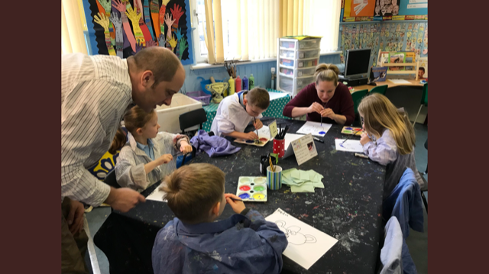 | 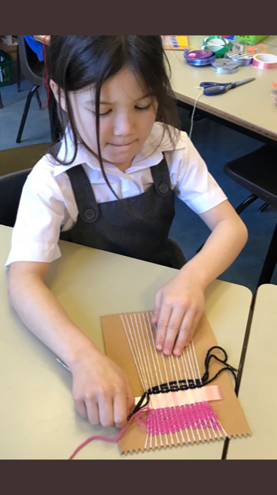

EXTRA CURRICULAR ACTIVITIES

Activities on offer to the pupils before and after school vary from year to year since the pattern of activities depends on the changing expertise and interests of staff and pupils. We work closely with our Active Sports co-ordinator, in order to provide more expert coaching in a variety of sports including lunchtime or after school clubs. As activities become available, we will communicate details by letter to pupils, parents and carers.

LOST PROPERTY

We cannot accept responsibility for personal items that are lost or damaged at school so we strongly recommend that children do not bring personal property, especially mobile phones, hand held computer games and collections of stickers or cards to school. All items brought to school should be clearly marked with your child’s name and class.

Any unclaimed items are stored in the Janitors office and parents can check by asking at the front office.

PLAYGROUND SUPERVISION

When pupils are at school, the responsibility for their safety rests with the Authority and the Head Teacher and Staff undertake this responsibility on behalf of the Authority. To ensure that accidents or difficulties can be reported to a responsible adult and appropriate action taken we employ playground supervisors and Learning Assistants in the playground during break times. P7 pupils act as Playground Helpers for the younger children.

Our Positive Behaviour Policy applies fully in the playground. It is important that basic rules of conduct are followed at all times to ensure safety and the consideration of others. We will do whatever is possible to ensure a safe and enjoyable playtime for the children, and our Learning Assistants and Playground Supervisors are expected to take reasonable steps to prevent accidents and to ensure that basic good conduct is maintained. However, it is not possible to guarantee that no such accidents will occur. In the event of any minor head knock, or other incident of concern, occurring during the school day, a note is sent home and parents are advised by telephone as soon as possible.

START OF THE DAY – SCHOOL OPENING

The authority does not provide playground supervisors in advance of the start of the school day and pupils are expected to arrive in school dressed for the prevailing conditions. However, in inclement weather, pupils are allowed access to the classrooms at 8:40, under the same conditions that apply during indoor intervals. The children are supervised in the building and so should be able to come into the building by themselves, rather than be accompanied by their parent/carer. This avoids congestion and health and safety issues of wet floors and buggies in corridors.

INDOOR INTERVALS

During inclement weather pupils remain in their classrooms over break and lunchtime periods. Should however, they place themselves or others at risk, through inappropriate poor or inconsiderate behaviour, this privilege will be removed.

PROMOTING POSITIVE BEHAVIOUR

Through promoting positive behaviour we aim to make Newtongrange Primary a school where everyone is respected, valued and has the opportunity to reach their full potential as effective citizens.

ALL STAFF

- Work together to create, develop and maintain a positive climate, ethos and relationship.
- Have high expectations of all learners.
- Recognise and reinforce positive achievements of learners.
- Help learners understand how to behave in acceptable ways.
- Be aware of and work within the systems, within the establishment to support learners towards achieving appropriate standards of behaviour.

OUR APPROACH IS:

- Restorative

Consistent

Appropriate

Relevant

Encouraging

Maintained
- Agreed

SCHOOL RULES

In Newtongrange Primary we have a minimal number of rules that are in effect at all times, in all activities, all day long.

Our rules are observable and continually in effect.

Our rules clearly tell pupils what behaviours are expected at all times.

These 3 rules are central to our approach to promoting positive behaviour.

- Do as you are asked
Teachers can’t teach and pupils won’t learn if directions are not followed.

- Use appropriate school language: no put downs, teasing or bad language All pupils and staff have the right to be in a school where they will not be verbally or psychologically humiliated.

- Keep hands, feet, and objects to yourself
For pupils and staff to feel safe in school they need to know that they are protected from being hit and that their property is protected from being taken or damaged.

School rules are discussed regularly through class discussions, Circle Time, School Council and assemblies.

The rules are on display in each classroom and throughout the school as a quick reference point.

WE ARE CURRENTLY REVIEWING OUR POSITIVE BEHAVIOUR POLICY (MARCH 2018)

ANTI-BULLYING POLICY

We aim to help prevent and deal with incidents of bullying in Newtongrange Primary and prepare children with the skills to combat bullying.

WHAT DO WE MEAN BY BULLYING?

There is no universal definition of bullying but it is generally agreed that the following features apply: -

- It is deliberately hurtful or aggressive behaviour.
- It is repeated over a period of time.
- Those being bullied feel it is difficult to stop the process.

People can be bullied for a number of reasons: -

- Being different in some obvious way e.g. race, gender, disability, nationality, language, religion, ability.
- Imagined differences.
- Lack of close friends/shyness.
- Sexual orientation.

Sometimes bullying can also be for NO APPARENT REASON.
It is always damaging and it is the policy of this school that it must always be taken seriously and addressed.

We take a proactive approach to preventing bullying in class activities and Assemblies.

- Talking about feelings and the kinds of behaviour that cause hurt to others.
- Encouraging children to think positively about differences.
- Introducing children through stories, pictures and positive role models to people from a wide variety of backgrounds.
- Ensuring through Circle Time and other P.S.D. activities that children have the opportunity to discuss any matters that are troubling them.

Whole School Initiatives include Anti-Bullying Assemblies, raising self esteem at Achievement Assemblies and discussion with the Pupil Council. We ensure that all people are welcomed, treated with equal value and that they feel safe.

All staff (including janitorial, secretarial, kitchen and other auxiliary staff) are made aware of the school anti-bullying policy so that they can play an active and positive role in implementing it.

DEALING WITH INCIDENTS

In this school the members of staff responsible for ensuring that anti-bullying procedures are followed are Miss Morgan, Mr McBride and Mrs Crossan. It is the responsibility of the designated person to ensure that all instances of bullying are investigated and recorded

Agreed behaviour changes and strategies for the bully are monitored on a daily basis.

If the unacceptable behaviour continues subsequent action may include:

- The pupil being removed from the playground at interval and lunch.
- Parents requested to deliver/collect pupil to and from school.
- In school/after school detention.
- Formal Exclusion following the authority Policy.
- In the case of peer physical or sexual assault the procedures in the Child Protection Guidelines must be followed. If the bullying involves extreme action e.g. assault, theft or extortion the parents of the victim will be informed of their right to inform the police as the allegations may result in a criminal offence.

CHILD PROTECTION

The Council has a range of duties and responsibilities in relation to the child protection procedures for all pupils which includes having regard for their right to be protected from harm and abuse. The school’s duties and responsibilities for this are set out in the Edinburgh and Lothians Child Protection Committee’s “Child Protection Guidelines” which are used by all Midlothian schools and our partner agencies.

In circumstances where a school has a significant concern that a child or young person has, or is at risk of being harmed or abused, the school is required to pass information to the Police, Social Work Department and Health colleagues who have a legal duty to investigate further. While we always endeavour to work in an open manner with parents and guardians, there are some circumstances when it may not be appropriate to inform the parent or guardian that a Child Protection referral has been made or that information has been passed on to these agencies. Under these circumstances, the decision as to when and how parents and guardians will be informed is the responsibility of the Police, Social Work and Health Services as part of their investigation and the school will be informed by these services of the action that they have taken.

Should you wish to discuss this or any associated matter further, please contact the Head Teacher, the school’s designated Child Protection Co-ordinator or the Information Officer, Co-ordinated Services for Children and Young People.

SCHOOL CLOSURES FOR OCCASIONAL AND EMERGENCY ARRANGEMENTS

Parents are informed by letter or newsletter in advance of planned closures for in service or holiday.

In the event of unplanned closure of the school, that is, in an emergency situation, parents will be informed by the most appropriate method. In the case of closure due to severe weather conditions, parents will be informed on arrival at the school and local radio will regularly broadcast information to parents.

It is against school policy for children to be allowed out of school unaccompanied. In an emergency situation, under no circumstances will children be sent home without a responsible adult to accompany them.

AFTER SCHOOL CLUB

Newtongrange After School Club is a registered childcare service provider, with qualified experienced staff. They are based at Newtongrange PS.

During term times, the Club runs:

- 2:30 pm – 5:45 pm Monday to Thursday
- 12:00 pm – 5:45 pm Fridays

During school holidays, the club runs:

- from 7:30 am – 5:45 pm Monday to Friday.

For more information please contact the Co-ordinator on 0131 561 9333.

COMPLAINTS PROCEDURES

PARENTS AND THE SCHOOL

Parents and schools separately can do a great deal to assist children’s educational development; together they can achieve more.

We will keep you informed of your child’s progress and we will deal confidentially with any information that will help us in planning her/his education.

We will keep you informed of our policies and procedures and will consult you whenever a significant change is contemplated.

We rely on your support and we welcome your comments on the school.

“The Education committee has approved the following statement of principles and procedures:

1 If you are concerned about...

... a particular aspect of our work, please arrange an appointment to discuss the matter with the Head Teacher in the first instance. Where appropriate, the Head Teacher may nominate another senior member of staff to act on her/his behalf.

The Head Teacher will listen carefully to what you have to say, establishing clearly the issue(s) of concern and, if appropriate, providing you with any relevant information.

In some cases, your concerns can be dealt with immediately; other matters may require more extended investigations.

In any event, the Head Teacher will notify you, normally within five working days, of the school’s response.

It is anticipated that, in most cases, the above steps will result in a satisfactory solution for all concerned.

2 If you are dissatisfied with the school’s response ...

... please notify the Head Teacher that you wish to pursue the matter further.

He/she will either review the proposed action or notify you of the appropriate officer* of the Education Authority whom you should contact (*see Useful Addresses).

Contact the named officer by telephone or by letter at Education Division Headquarters.

The officer will investigate the matter and endeavour to resolve any difficulties. He/she will report the outcome to you, normally within five working days of being contacted.

3 Nearly all matters of concern are resolved through the above procedures. If you remain dissatisfied, please contact, again, the officer involved at stage 2; he/she will review the situation and/or indicate what other avenues are open to you.

4 In all cases, unresolved matters may be finally referred to the Chief Executive’s office.

USEFUL ADDRESSES

Chief Executive | Kenneth Lawrie | 0131 271 3002
Director, Education, Communities and Economy  (PA Cathy Lailvaux) | Mary Smith | 0131 271 3718
Head of Education  (PA Julie Currie) | Grace Vickers | 0131 271 3719
Head of Communities and Economy  (PA Julie Currie/Lorraine O’Malley) | Ian Johnson | 0131 271 3460
Head of Children & Families  (PA Lorraine O’Malley) | Joan Tranent | 0131 271 3721
Schools Group Managers | Nicola McDowell  Julie Fox  Craig Biddick  Andrew Sheridan  Maria Lloyd | 0131 271 3726  0131 271 3725  0131 271 3723  0131 271 3701  0131 271 3724
Education Support Officer (ASL)  Development Officer (ASL) | Laurinda Renton  Isobel Roast | 0131 271 3737  0131 271 3689
Principal Educational Psychologist | Leisa Randall | 0131 271 6686
Manager, Lifelong Learning | Annette Lang | 0131 271 3923
Education Support Officer, NQTs, etc | Sharon Smith | 0131 271 3722
Placing Requests, and Primary School Swimming Programme | Fiona Campbell | 0131 271 3733
Education Maintenance Allowance | Valarie Smith  Barbara Scott | 0131 271 3772  0131 270 6765
Free School Meals and Clothing Grants | Nicky McLean | 0131 271 3655
School Lets | Business Services Support | 0131 271 3705
Parent Councils | Shona Mackie | 0131 271 3739
Home to School Transport Section | Debbie Hunter | 0131 561 5453
Early Years Manager | Rob Beal | 0131 271 3694

